Interactive Dashboard &
Tableau Storytelling

Assignment_32

Hospital Management Data Analysis

Dataset: Hospital_management.xlsx | Total Records: 260
Submitted to: PW Skills

Q1. Tableau Dashboard vs Tableau Story Point
Question: Explain the difference between a Tableau Dashboard and a Tableau Story Point. Give two healthcare-related use cases.

Answer:

Aspect | Tableau Dashboard | Tableau Story Point
Definition | A single view that combines multiple worksheets and objects into one interactive canvas. | A sequence of visualizations presented as slides to narrate data insights step by step.
Purpose | Provides a real-time operational overview with filters, KPIs, and interactivity. | Guides the audience through a structured data narrative or analytical journey.
Interaction | Users explore data interactively using filters, actions, and drill-downs. | Users navigate through story points sequentially, like a presentation.
Use Case | Monitoring live hospital metrics like bed occupancy, patient inflow, etc. | Presenting a quarterly report of patient trends and treatment outcomes to management.
Components | Worksheets, images, text boxes, filters, legends. | Story points, captions, dashboards, or single worksheets as slides.

Two Healthcare-Related Use Cases:

Use Case 1 — Dashboard: A Hospital Operations Dashboard displaying real-time metrics such as total patients admitted per region, department-wise bed occupancy, treatment costs, and critical patient count. The management can apply filters by department or region to take instant operational decisions.

Use Case 2 — Story Point: A Quarterly Patient Outcome Report Story that guides stakeholders through a narrative: starting with patient distribution by region (Story Point 1), moving to department-wise cost analysis (Story Point 2), then outcome distribution (Story Point 3), and finally doctor performance (Story Point 4). Each point includes annotation and insights.

Q2. Actions in Tableau & Filter Action
Question: What are Actions in Tableau? Explain how Filter Action can help hospital management analyze patient data.

Answer:
Actions in Tableau are interactive features that allow users to interact with the visualization to change the view, highlight data, filter content, or navigate to URLs. Actions make dashboards dynamic and user-driven.

Types of Tableau Actions:
- Filter Action – Filters data in one or more target sheets based on a selection made in a source sheet.
- Highlight Action – Highlights related data marks across multiple sheets without removing other data.
- URL Action – Opens a web URL based on a data value (e.g., opening a patient record system).
- Go to Sheet Action – Navigates to another dashboard or sheet.
- Set Action – Adds or removes values from a set based on user selection.

How Filter Action Helps Hospital Management:
A Filter Action in the Hospital Management Dashboard can be configured so that when a manager clicks on a specific Hospital Region in the bar chart (e.g., "West"), all other connected charts — such as Department Cost, Outcome Distribution, and Doctor Performance — automatically update to show only data for that region.

🏥 Practical Hospital Scenario:
Step 1: Manager clicks on "West" region in the Patient Distribution bar chart.
Step 2: Filter Action triggers — all other sheets filter to show only West region data.
Step 3: Department Cost chart updates to show only West region department costs.
Step 4: Outcome Pie Chart updates to show West region patient outcomes.
Result: Management instantly understands how the West region is performing without manually adjusting multiple filters.

This is configured in Tableau via: Dashboard → Actions → Add Action → Filter → Source Sheet (Region Chart) → Target Sheets (All other sheets) → Run on: Select.

Q3. Patient Distribution – Bar Chart by Hospital Region
Question: Create a Bar Chart showing Total Patients by Hospital Region. Add this as a Story Point with proper title.

Answer – Tableau Steps:
- Open Tableau → Connect to Hospital_management.xlsx.
- Drag "Hospital Region" to Columns shelf.
- Drag "Patient ID" to Rows shelf → Change aggregation to COUNT.
- Sort bars in descending order by clicking the sort icon on the axis.
- Add "Hospital Region" to Color shelf for distinct region colors.
- Add "CNT(Patient ID)" to Labels shelf to show count on each bar.
- Title the sheet: "Total Patients by Hospital Region".
- Go to Story → New Story Point → Drag this sheet → Add caption: "Story Point 1: Patient Distribution by Region".

– Q3: Total Patients by Hospital Region
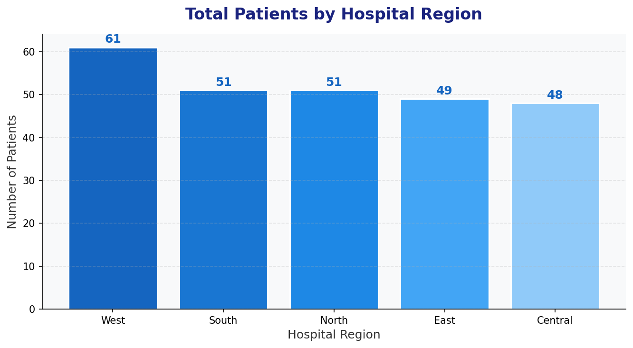

📊 Insights from Patient Distribution Chart:
• West region has the highest patient count with 61 patients (23.5% of total).
• South and North regions each have 51 patients (tied second).
• East has 49 patients and Central has 48 patients.
• The distribution is relatively balanced, suggesting uniform hospital coverage across regions.
• West region may require more resources/staff due to highest patient load.

Q4. Department Performance – Treatment Cost by Department
Question: Create a visualization showing Treatment Cost by Department. Add labels and customize colors.

Answer – Tableau Steps:
- In a new sheet, drag "Department" to Rows shelf.
- Drag "Treatment Cost" to Columns shelf → Aggregation: SUM.
- Sort by descending order of SUM(Treatment Cost).
- Drag "Department" to Color shelf → Click Color → Edit Colors → Assign custom colors per department.
- Drag "SUM(Treatment Cost)" to Labels shelf → Format as currency → Click Label → Show Mark Labels.
- Right-click Y-axis → Format → Currency format.
- Title: "Treatment Cost by Department".

– Q4: Treatment Cost by Department
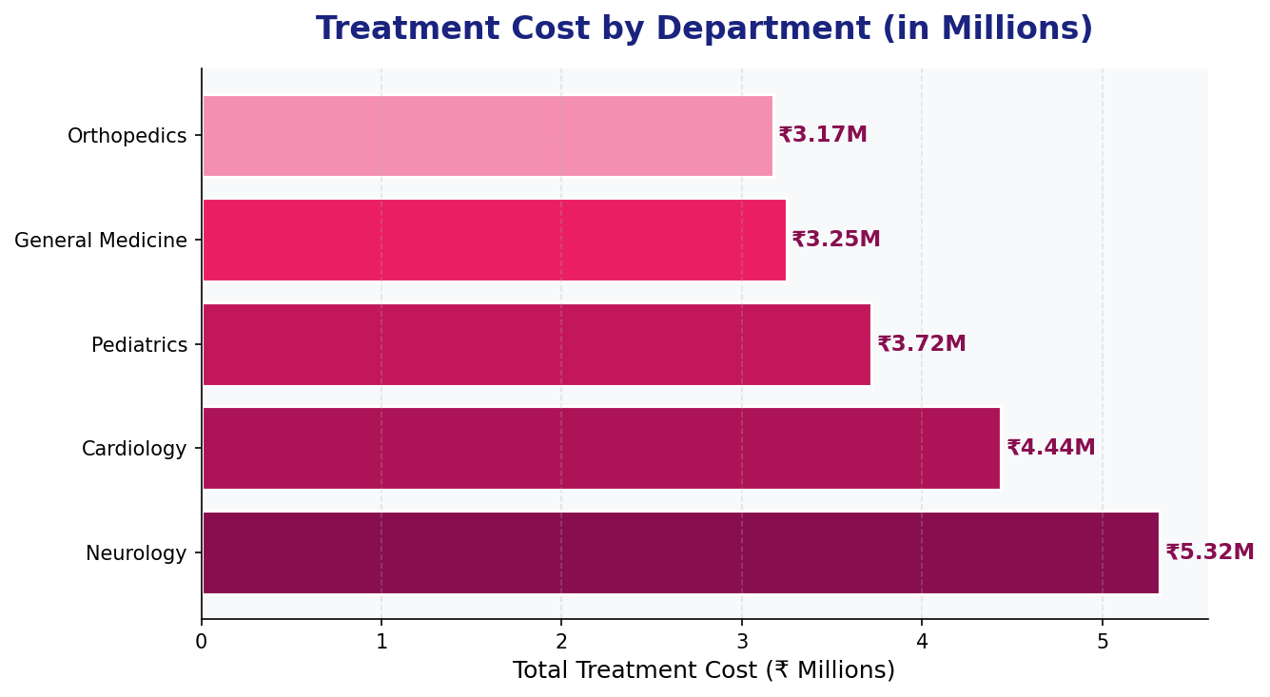

📊 Insights from Department Performance:
• Neurology has the highest treatment cost at ₹53.20 Lakhs, indicating complex/expensive procedures.
• Cardiology is second at ₹44.38 Lakhs — both departments together account for 49.2% of total costs.
• Pediatrics (₹37.2L), General Medicine (₹32.5L), and Orthopedics (₹31.7L) have lower but significant costs.
• Hospital management should allocate higher budgets to Neurology and Cardiology departments.

Q5. Treatment Trend Over Time – Line Chart (Mar–Sep)
Question: Create a Line Chart: Treatment Cost vs Admission Date. Filter the data only from March to September.

Answer – Tableau Steps:
- Drag "Admission Date" to Columns shelf → Change date level to MONTH.
- Drag "Treatment Cost" to Rows shelf → Aggregation: SUM.
- Change mark type to Line from the Marks card.
- To filter March–September: Drag "Admission Date" to Filters shelf → Select "Range of Dates" or "Month/Year" → Check months March through September.
- Add "SUM(Treatment Cost)" to Labels → Show at end of line or each point.
- Customize line color to blue, add tooltips with month and cost.
- Title: "Treatment Cost Trend: March to September 2024".

– Q5: Treatment Cost Trend (Mar–Sep 2024)
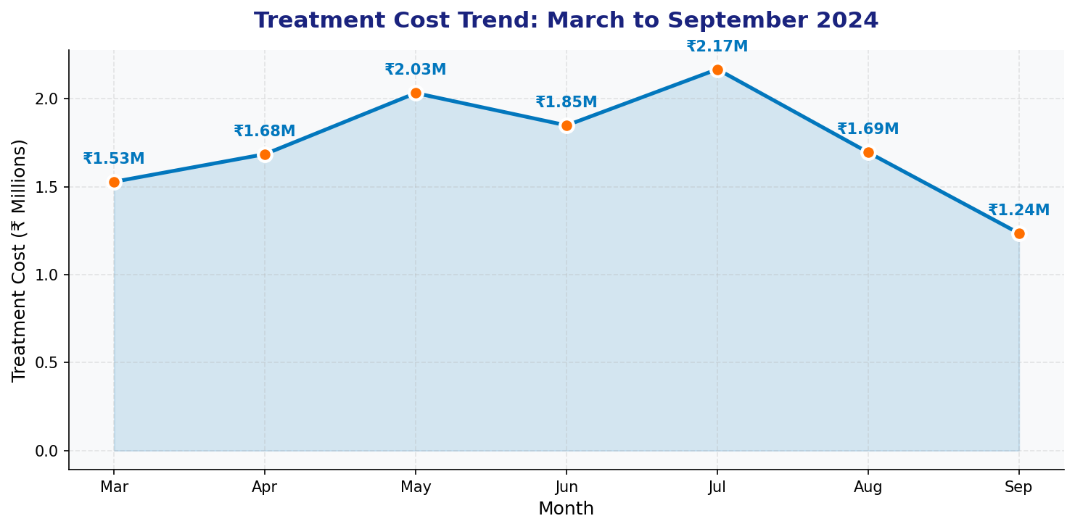

📊 Insights from Treatment Trend:
• Treatment costs show an upward trend from March (₹15.28L) to July (₹21.67L) — peak month.
• July records the highest monthly cost at ₹21.67 Lakhs, suggesting peak admissions or complex cases.
• September shows a sharp decline to ₹12.35 Lakhs — lowest in the filtered period.
• May–July is the high-cost period; hospital should plan resource allocation accordingly.
• The peak in July may correlate with seasonal illnesses or increased patient inflow.

Q6. Outcome Analysis – Pie Chart
Question: Create a Pie Chart: Patient Outcome Distribution (Recovered / Critical / Under Treatment).

Answer – Tableau Steps:
- In a new sheet, select "Pie" from the Marks card dropdown.
- Drag "Outcome" to Color shelf → Each outcome gets a distinct color.
- Drag "Patient ID" to Angle shelf → Aggregation: COUNT.
- Drag "Patient ID" (COUNT) and "Outcome" to Labels shelf.
- Format Labels: Show percentage → Right-click label → Format → Add % calculation.
- Assign colors: Recovered = Green, Critical = Red, Under Treatment = Amber.
- Title: "Patient Outcome Distribution".

– Q6: Patient Outcome Distribution
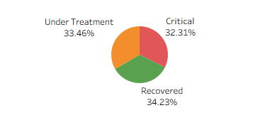

📊 Insights from Outcome Analysis:
• Recovered: 89 patients (34.2%) — highest outcome category, indicating good treatment success.
• Under Treatment: 87 patients (33.5%) — ongoing cases requiring continued care.
• Critical: 84 patients (32.3%) — alarmingly high proportion requiring urgent management attention.
• The near-equal split across three outcomes suggests a challenging patient mix.
• Hospital should investigate why 32.3% of patients are in critical condition and intervene early.

Q7. Doctor Performance & Patient KPI Analysis
Question Part A: Create a Ranked Bar Chart showing Top Doctors by Total Treatment Cost handled.
Question Part B: Create a KPI visualization showing Total Patients Treated.

Part A – Doctor Performance: Tableau Steps:
- Drag "Doctor Name" to Rows shelf.
- Drag "Treatment Cost" to Columns shelf → Aggregation: SUM.
- Sort in descending order: Right-click axis → Sort → Descending → by Field → SUM(Treatment Cost).
- Add "Doctor Name" to Color shelf for distinct colors.
- Add "SUM(Treatment Cost)" to Labels shelf, format as currency.
- To add Rank: Create a Calculated Field → RANK(SUM([Treatment Cost])) → Add to Rows.
- Title: "Top Doctors by Total Treatment Cost Handled".

– Q7A: Doctor Performance Ranked Bar Chart
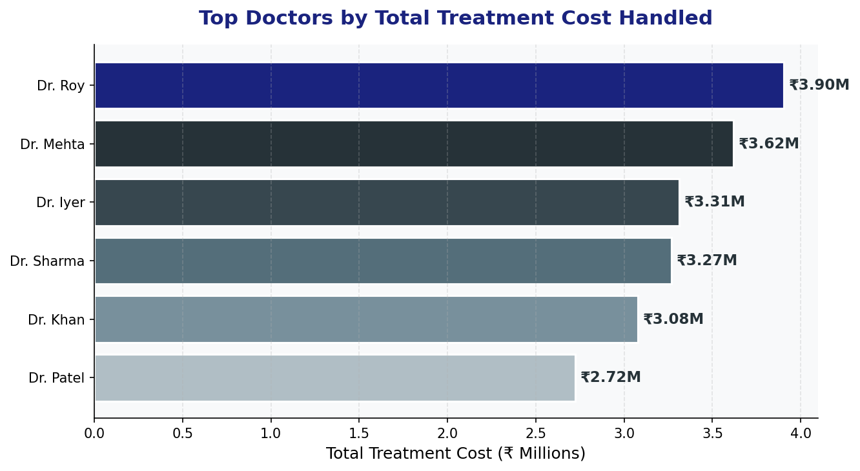

Part B – KPI Visualization: Tableau Steps:
- Create a new sheet → Drag "Patient ID" to Text in Marks card → Aggregation: COUNT.
- Change mark type to "Text" or use a "Big Number" KPI layout.
- Add a Reference Line or format the number large for a KPI card effect.
- Title: "Total Patients Treated: 260".

– Q7B: KPI Dashboard
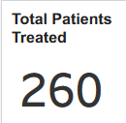

📊 Insights from Doctor Performance:
• Dr. Roy handles the highest treatment cost at ₹39.03 Lakhs — top performing doctor by cost.
• Dr. Mehta follows at ₹36.18 Lakhs, and Dr. Iyer at ₹33.11 Lakhs.
• Dr. Patel handles the lowest cost (₹27.23L), possibly handling lower-severity cases.
• KPI: Total 260 patients treated across all departments and regions.
• Hospital can use this to incentivize top doctors and distribute workload equitably.

Q8. Interactive Dashboard
Question: Build a Dashboard containing Region Chart, Department Cost Chart, Outcome Chart. Add Filters: Hospital Region, Department.

Answer – Tableau Steps:
- Click "New Dashboard" at the bottom of Tableau.
- Set Dashboard Size: Automatic or Fixed (1200 x 800 px recommended).
- Drag Sheet 1 (Region Bar Chart) to the top-left of the dashboard canvas.
- Drag Sheet 2 (Department Cost Chart) to the top-right area.
- Drag Sheet 3 (Outcome Pie Chart) to the bottom area.

Adding Filters:
- Click on the Region Chart → Click the dropdown arrow on the sheet → Filters → Hospital Region → Add to Dashboard → Apply to All Worksheets.
- Click on Department Cost Chart → Filters → Department → Add to Dashboard → Apply to All Worksheets.
- Show Filter controls will appear as dropdown or slider on the dashboard.

Adding Filter Actions:
- Dashboard Menu → Actions → Add Action → Filter.
- Source Sheet: Region Chart | Run on: Select | Target: All Sheets.
- This enables click-to-filter behavior across all charts.

Adding Titles & Formatting:
- Add a Text Object at top as Dashboard Title: "Hospital Management Interactive Dashboard".
- Format background color, add borders, and adjust layout for readability.
- Add a floating KPI text showing "Total Patients: 260 | Total Cost: ₹1.99 Cr".

🏥 Dashboard Design Tips:
• Use a consistent color palette (blues for regions, reds/pinks for departments, greens/reds for outcomes).
• Ensure the title is prominent with hospital branding.
• Add tooltips with detailed info on hover for each visualization.
• Test all filter actions by clicking regions and departments to verify cross-filtering works.
• Add a "Reset Filters" button using a navigation action for user convenience.

Q9. Storytelling Flow – Tableau Story
Question: Create a Tableau Story with minimum 4 Story Points: Patient Distribution, Department Cost Analysis, Outcome Analysis, Doctor Performance.

Answer – Tableau Steps to Create Story:
- Click "New Story" at the bottom of Tableau Desktop.
- Set Story title: "Hospital Management Insights – A Data Story".

Story Point 1 – Patient Distribution
- Drag Sheet "Total Patients by Hospital Region" onto the canvas.
- Add Story Caption: "Story Point 1: Regional Patient Distribution".
- Add annotation: "West region leads with 61 patients; all regions show balanced distribution."

Story Point 2 – Department Cost Analysis
- Click "Blank" to add a new story point.
- Drag Sheet "Treatment Cost by Department" onto canvas.
- Caption: "Story Point 2: Department-wise Treatment Cost".
- Annotation: "Neurology and Cardiology together account for 49% of total hospital costs."

Story Point 3 – Outcome Analysis
- Click "Blank" for Story Point 3.
- Drag Outcome Pie Chart sheet.
- Caption: "Story Point 3: Patient Outcome Distribution".
- Annotation: "32.3% patients are Critical — urgent intervention needed."

Story Point 4 – Doctor Performance
- Click "Blank" for Story Point 4.
- Drag Doctor Performance ranked bar chart.
- Caption: "Story Point 4: Doctor Performance by Treatment Cost".
- Annotation: "Dr. Roy handles highest cost cases; equitable workload distribution recommended."

📊 Story Navigation in Tableau:
• Story points appear as tabs/panels at the top of the Story canvas.
• Each story point can contain a Dashboard, a single sheet, or a blank with annotations.
• Use the "Add a caption" box to provide context for each story point.
• Present the story in Presentation Mode (F7) for a clean, full-screen view.
• Publish to Tableau Public/Server for stakeholder sharing.

Q10. Business Insights – Data-Driven Decisions
Question: Based on your visuals, answer: (1) Which department generates the highest treatment cost? (2) Which region has more critical patients? (3) What business decisions can hospital management take from these insights?

Answer 1: Department with Highest Treatment Cost
Based on the Department Performance visualization, Neurology generates the highest treatment cost with a total of ₹53,20,473.65 (₹53.20 Lakhs). This is followed by Cardiology at ₹44.38 Lakhs. Neurology procedures such as brain surgeries, MRI scans, ICU care, and specialized neurological treatments are inherently expensive and resource-intensive, which explains the highest cost figure.

Answer 2: Region with More Critical Patients
Both West and South regions are tied for the highest number of critical patients, each with 20 critical cases. West leads in total patient count (61) and shares the top spot in critical patients (20), suggesting that West has the most intensive care requirements. North follows with 16 critical patients, Central with 15, and East with 13.

Answer 3: Business Decisions for Hospital Management

Decision 1: Resource Allocation for Neurology
Since Neurology incurs the highest treatment cost (₹53.2L), hospital management should:
• Increase budget allocation for Neurology equipment and specialist recruitment.
• Negotiate better rates with neurology equipment suppliers.
• Consider establishing a dedicated Neurology Excellence Center.

Decision 2: Critical Patient Management in West & South Regions
Both West and South regions have 20 critical patients each:
• Deploy additional ICU beds and critical care specialists in West and South hospitals.
• Set up rapid response teams and emergency protocols specific to these regions.
• Investigate root causes — are critical cases due to delayed admissions, specific diagnoses, or demographics?

Decision 3: July Peak Period Preparedness
Treatment costs peak in July (₹21.67 Lakhs):
• Hire temporary/contract staff before peak season (May–July).
• Increase medical supply procurement in advance.
• Pre-authorize insurance claims and ensure financial reserves during peak months.

Decision 4: Doctor Workload Optimization
Dr. Roy handles disproportionately high-cost cases (₹39L):
• Redistribute complex cases among top doctors to prevent burnout.
• Provide performance bonuses to high-performing doctors.
• Monitor Dr. Patel's lower cost portfolio — may indicate simpler cases or under-utilization.

Decision 5: Outcome Improvement Strategy
32.3% of patients are in Critical condition — this is concerning:
• Implement early warning systems and patient monitoring protocols.
• Analyze which departments and regions contribute most to critical outcomes.
• Invest in preventive care programs to reduce critical admissions.
• Target reducing critical patients to below 20% through improved triage and early treatment protocols.

End of Assignment – Interactive Dashboard & Tableau Storytelling_32

